THE STATE UNIVERSITY OF ZANZIBAR
Department of Computer Science and IT
Course Code: INF CS2106 ; Course Name: Data Structure and Algorithms
Mid Term Test TIME 1 Hr Answer all Questions Date: 16th January, 2020
- Use the postfix to infix algorithm to transform the following expressions into its infix form, then evaluate the expression following values for identifiers: A=8, B=7, C=5, D=3, and E=1. Show the content of the stack each time you scan a new token from the expression: [10 marks]
- B D + C / E ^ A *
- E D + B C - * A /
- Use the infix to postfix algorithm to transform the following expressions into its postifx form. Show the content of the stack and postfix list each time you scan a new token from the expression: [10 marks]
- (A + C) / D ^ E * B
- B + E – (A + B ) ^ C / D
- Given the following sorted linked list, write the code to perform the following operations: [20 marks]
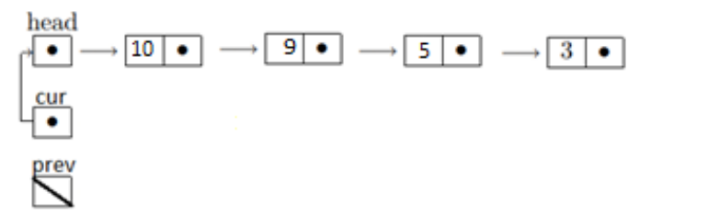
- Create a new node (toBeInserted) having value ‘4’ and, find the right position to insert it (between 5 and 3) and insert in the sorted list.
- Delete the last node in the linked list (that has value 3)
- Delete the first node in the linked list (that has value 10)
- Traverse the linked list and count the number of elements in the list that are greater than 5.
- Draw a binary tree that contain the letters “b”, “n”, “o”, “s”, “u” such that the inorder traversal spells “bonus” and the preorder traversal spells “obuns” [10 marks]
- Please provide short answers (3 sentence maximum) for each question. [10 marks]
  - If we are using an ArrayList as the main data structure in an implementation of the OrderedList interface, what is the best asymptotic runtime in terms of n, the number of elements in the list, of the method that can be used to find a key in that ArrayList?
  - If we push “s”, “w”, “a”, “t” onto a stack, what letter will be returned when we pop() from the stack?
  - If we enqueue “s”, “w”, “a”, “t” onto a queue, what letter will be returned when we dequeue() from the queue?
  - List one advantage of a linked list over an array
  - List one advantage of an array over a linked list.

